In the past 21 years, different teachers in my life taught me the history of world and history of China. However, none of them tell me details of the late 19th century history of China. Today I find a book “History of Northern Warlords” which written by Xinxia Lai(来新夏) at 1999(Qigong is one of his teacher). He was the curator of Nankai University Library. I really think he is a pure scholar mainly because his devotion in exploring the history.

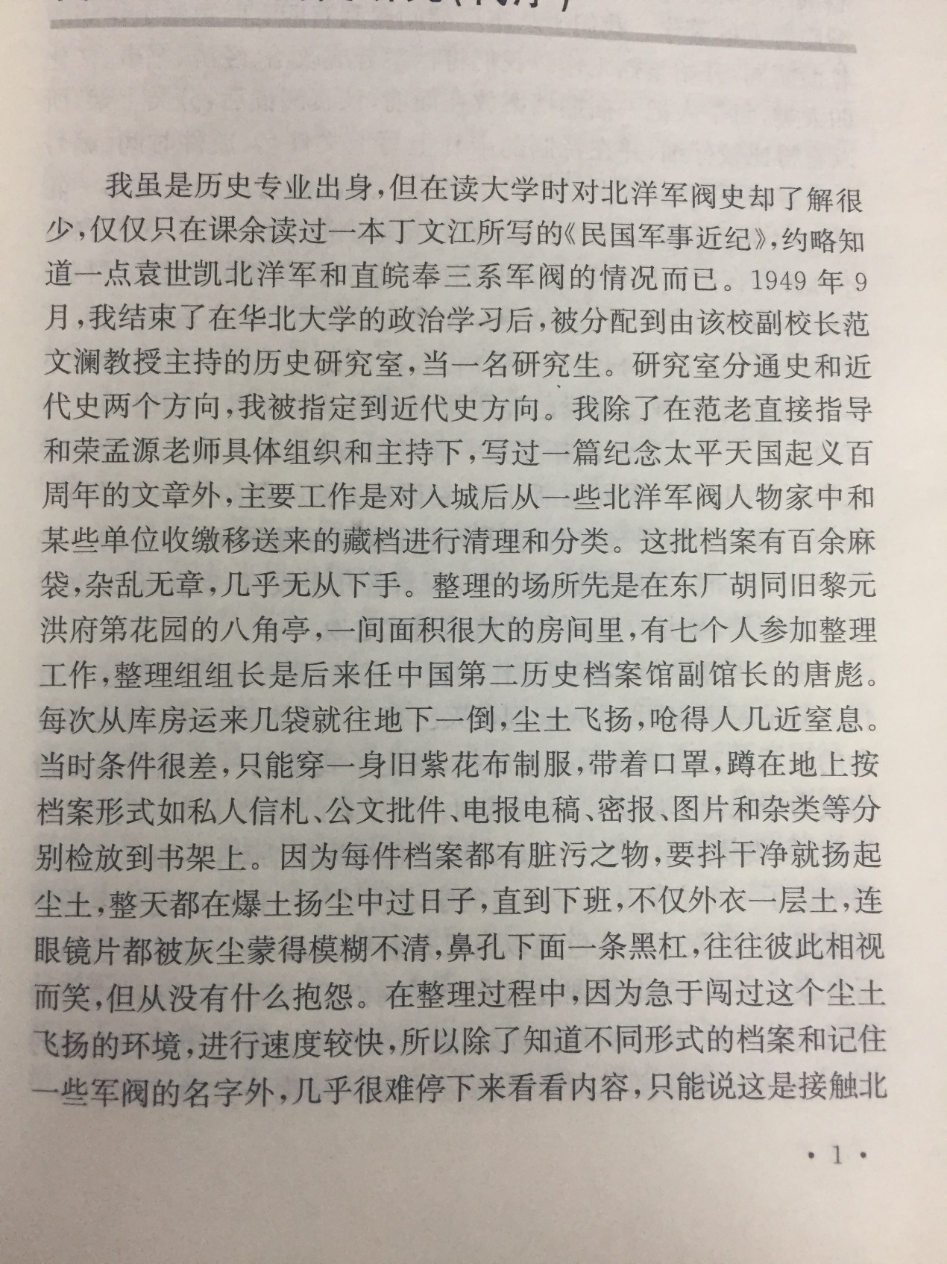

From the picture above, people can see his passion in the major of history especially the late 19th century. And in this reading note, I’d like to explore the history of late 19th century with this honorific scholar.

People don’t like to recall the situations which make them felling awkward,